**Practical No. 9**

1. **Using Packet Tracer, create a wireless network of**

**multiple PCs using appropriate access point.**

**Step 1: Take Router. Network devices – Wireless Devices –**

**Take Router WRT300N**

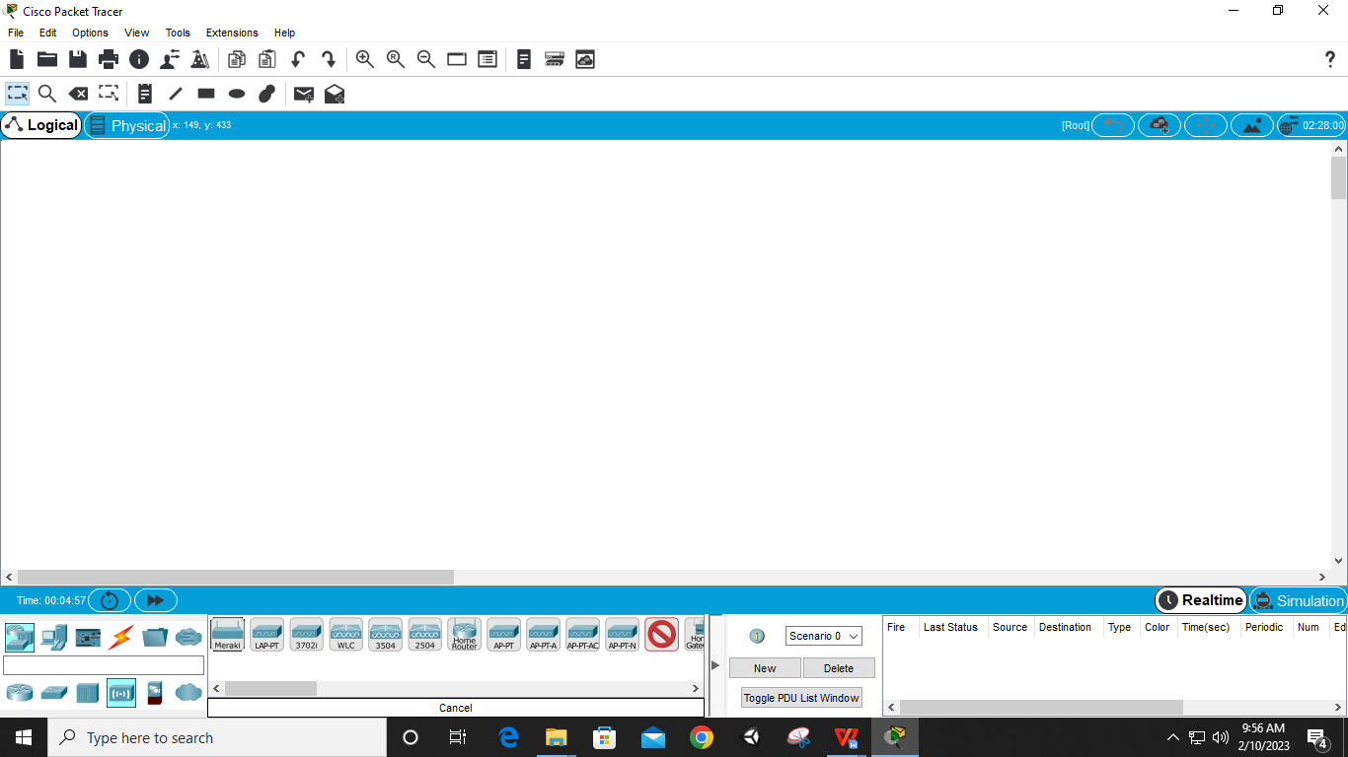

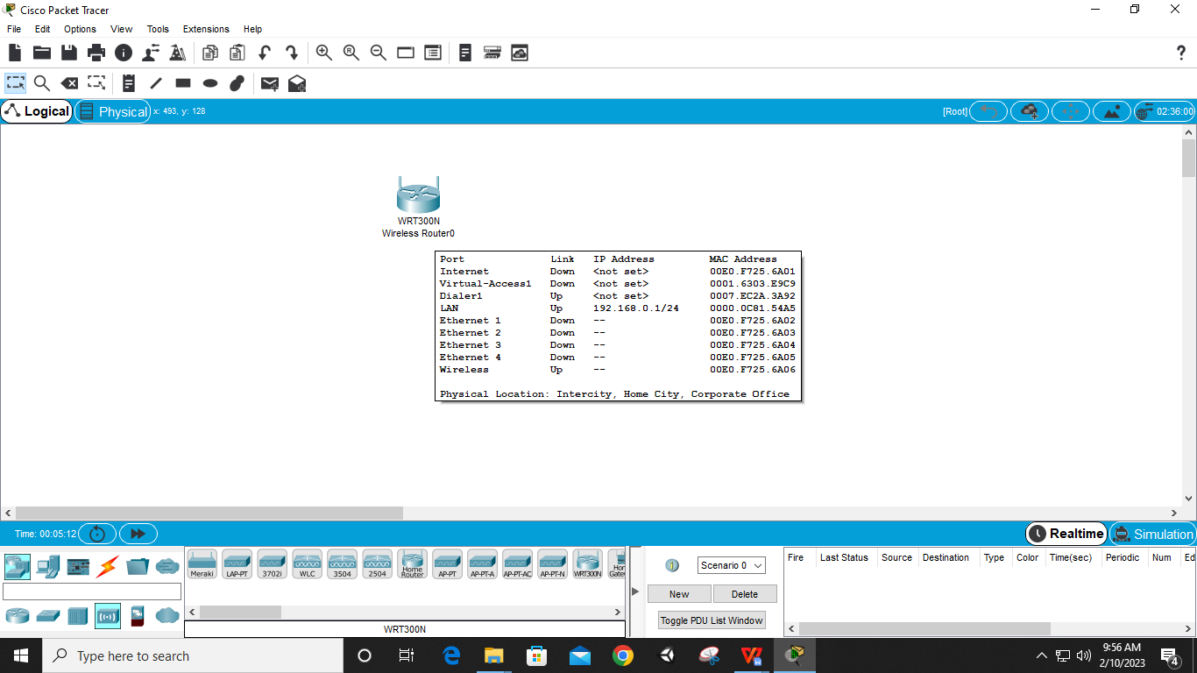

**Step 2: Take 3 PCs**

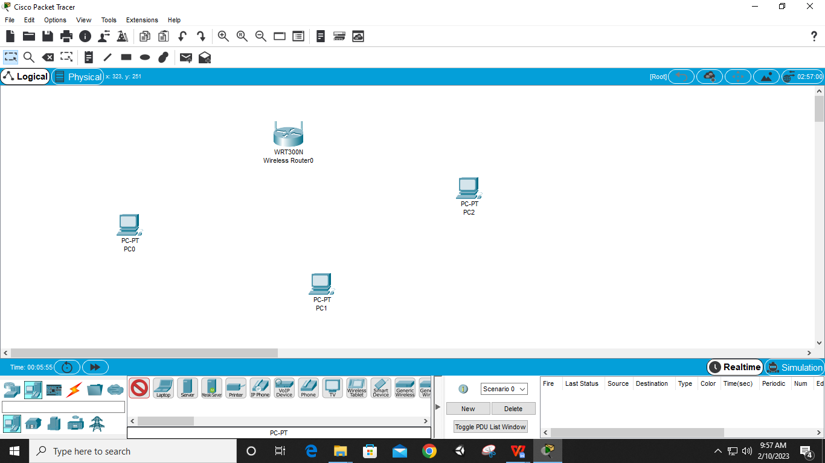

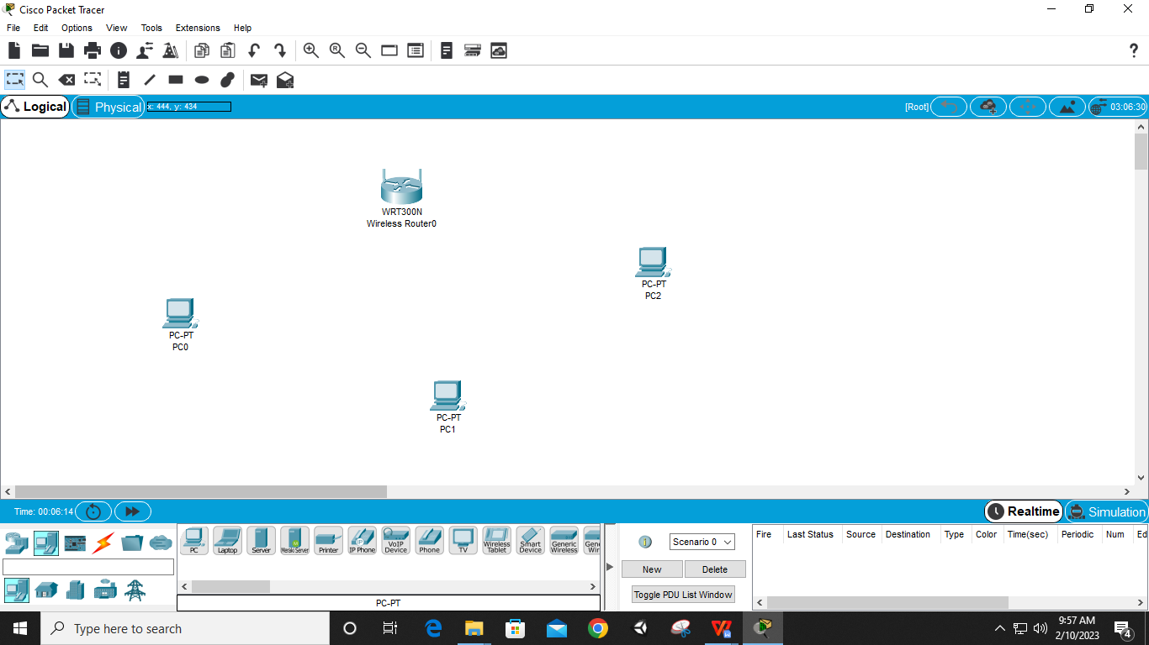

**Step 3: Select Router – GUI – Setup – IP Address ‘192.168.0.1’ – Disable DHCP – Save**

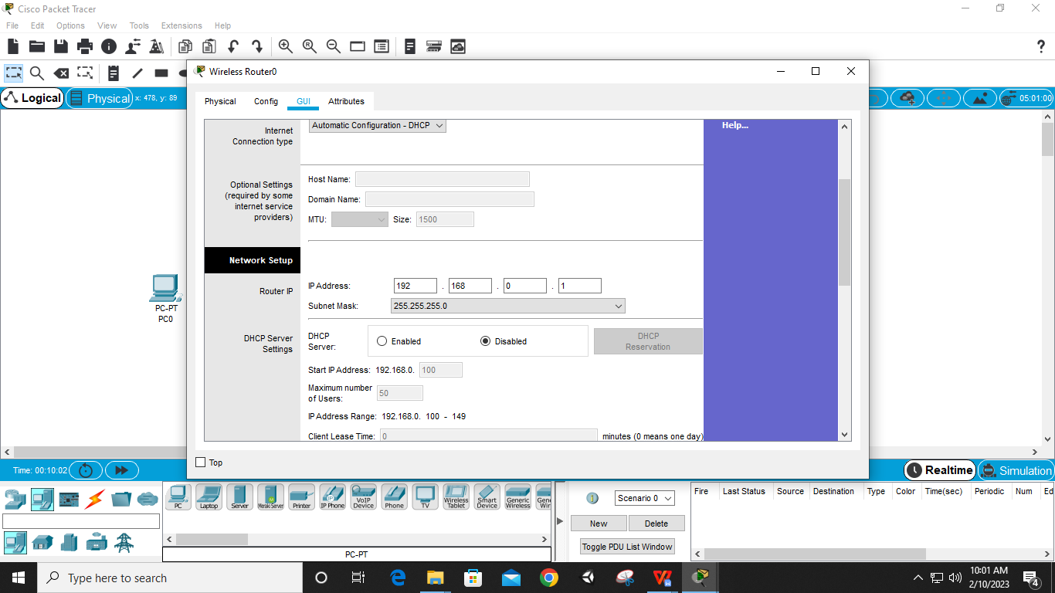

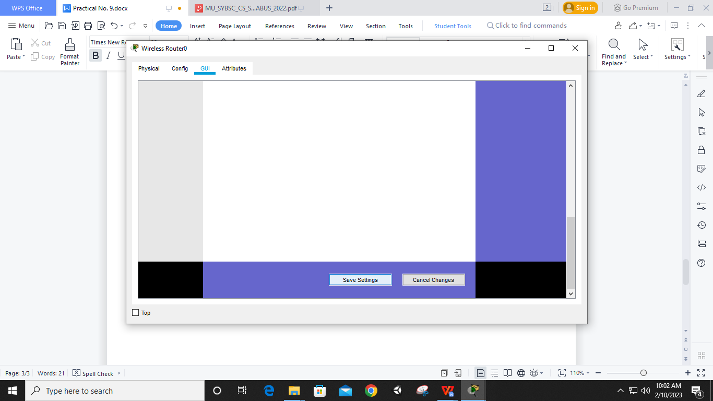

**Step 4: In Router – Wireless – Basic wireless settings – network name (SSID) ‘mynetwork’ – Save**

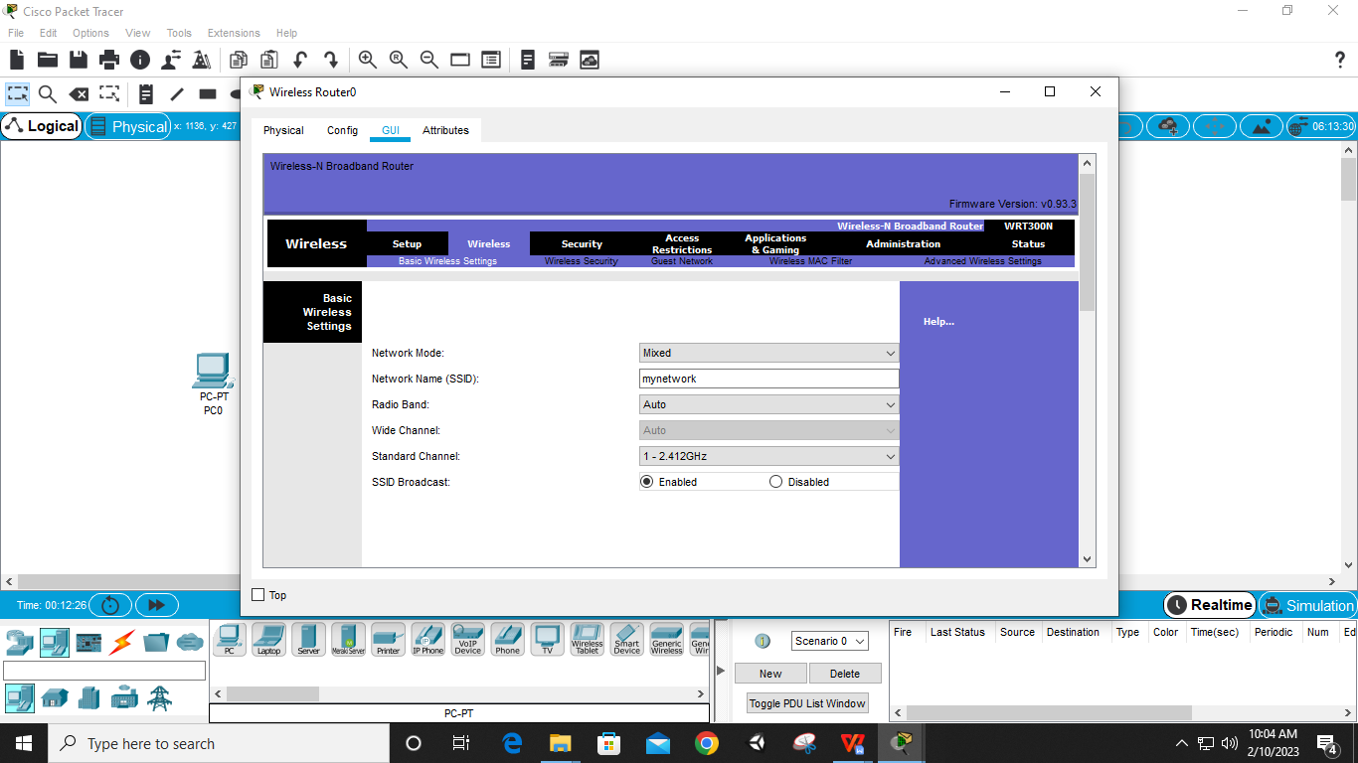

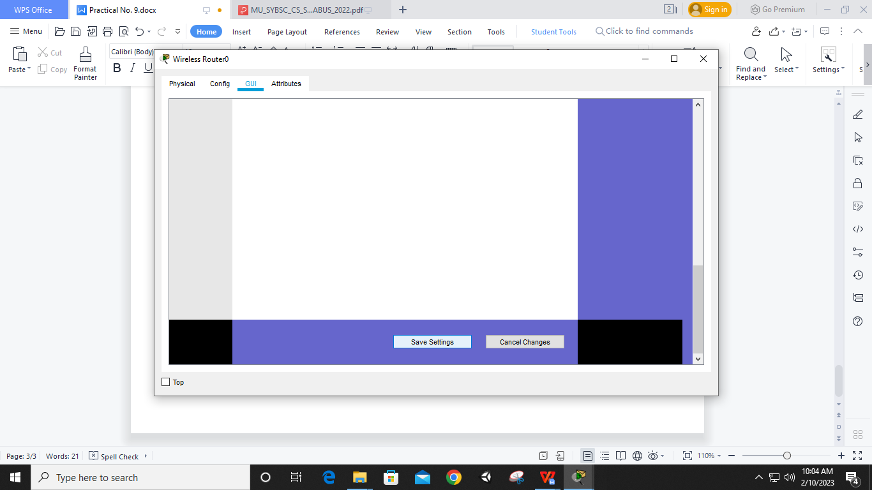

**Step 5: In Router – Wireless – Wireless Security – Wireless Mode ‘WEP’ – key1 ‘0123456789’ – Save**

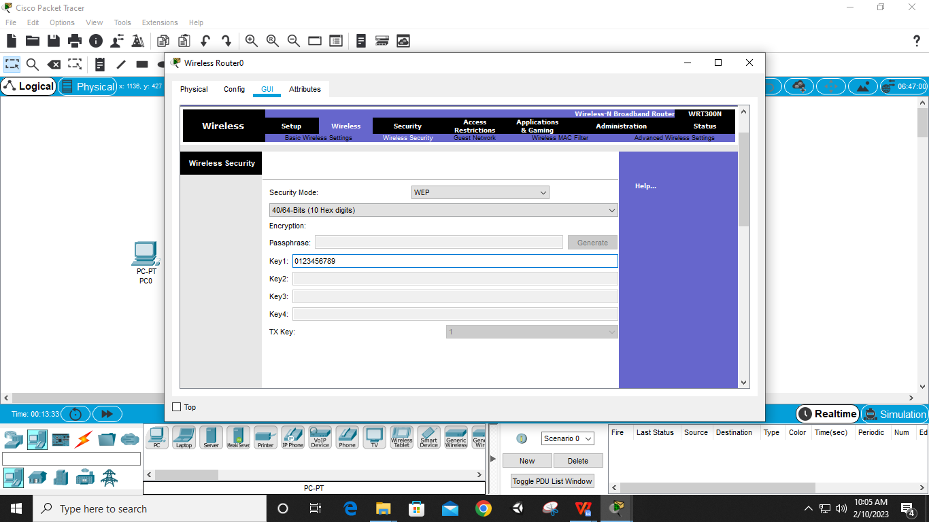

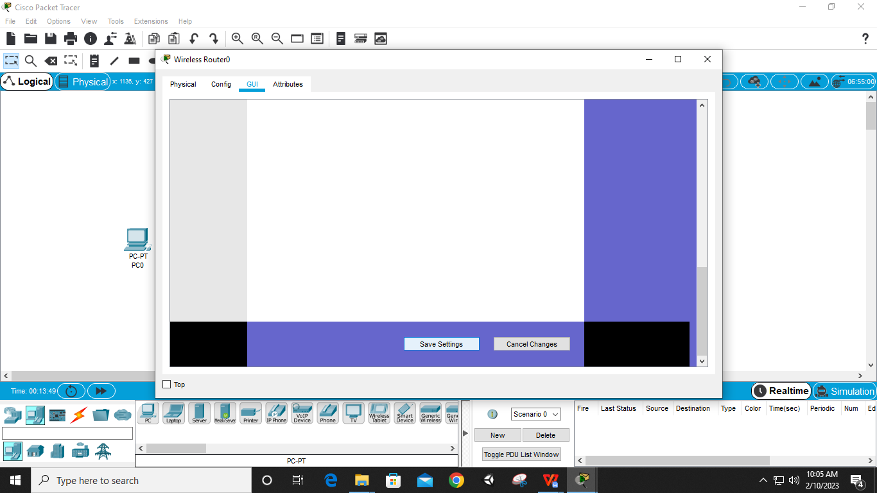

**Step 6: Select PC – Physical – CPU OFF – Cancel Port – Use port ‘WMP300N’ – CPU ON (for all PCs)**

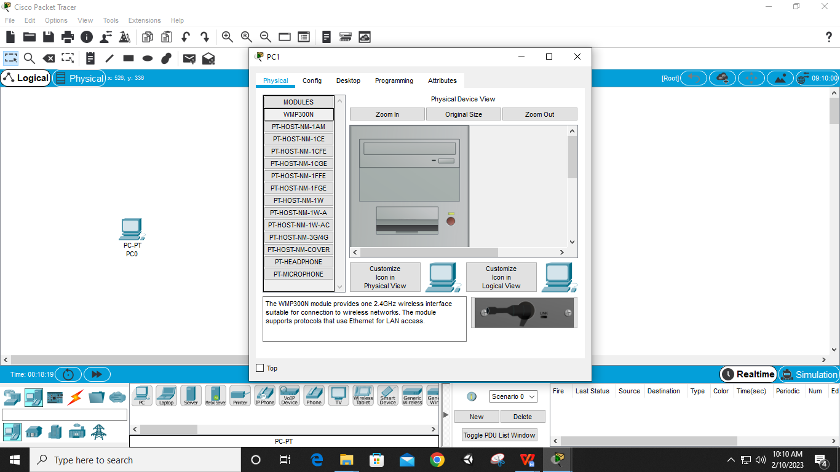

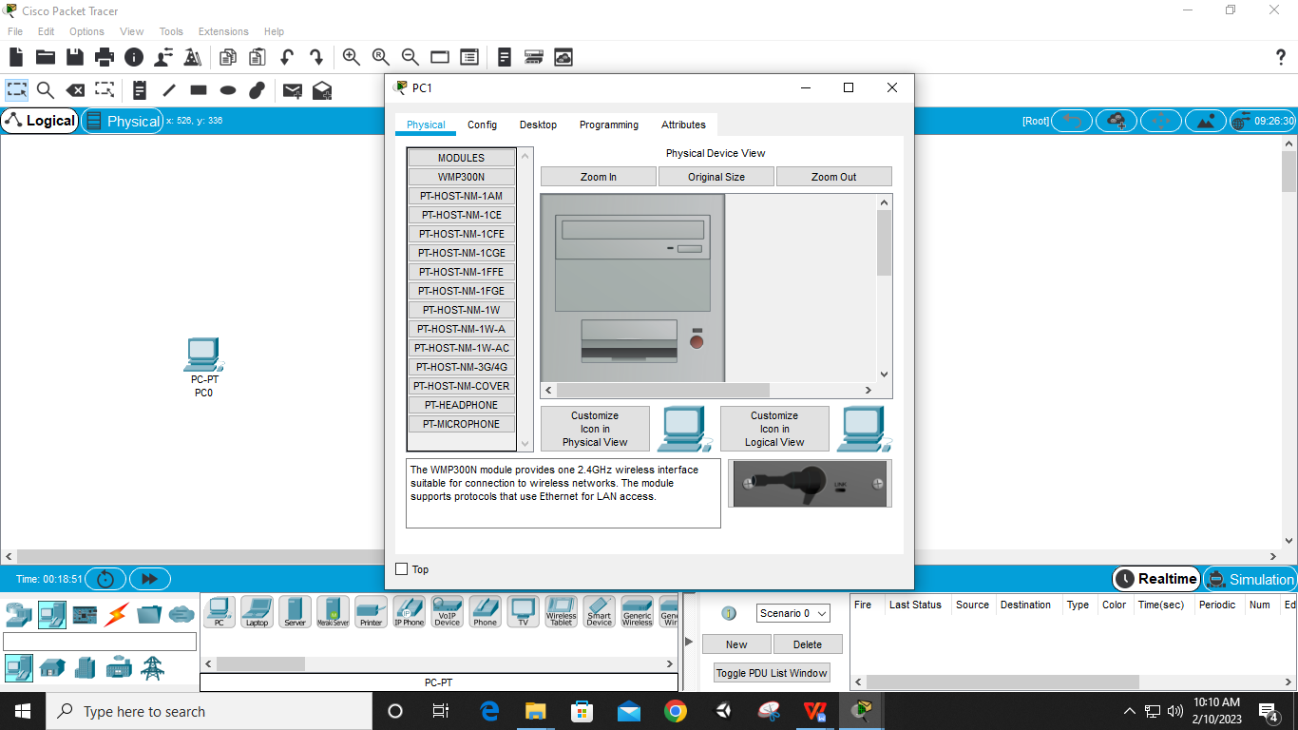

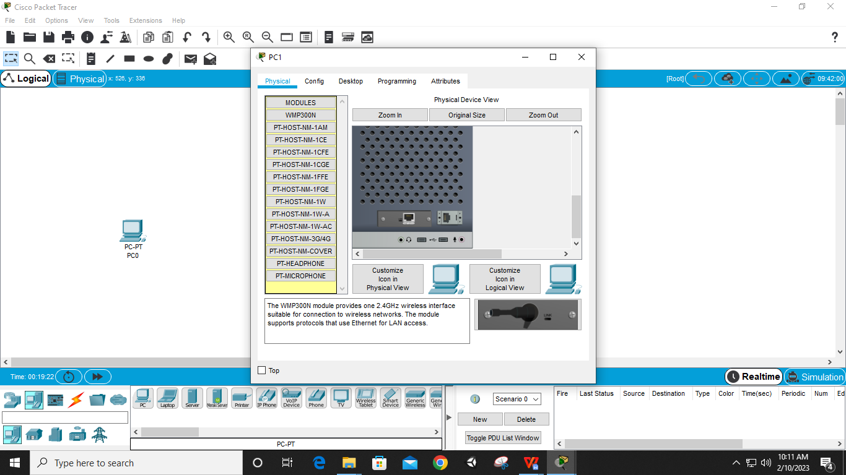

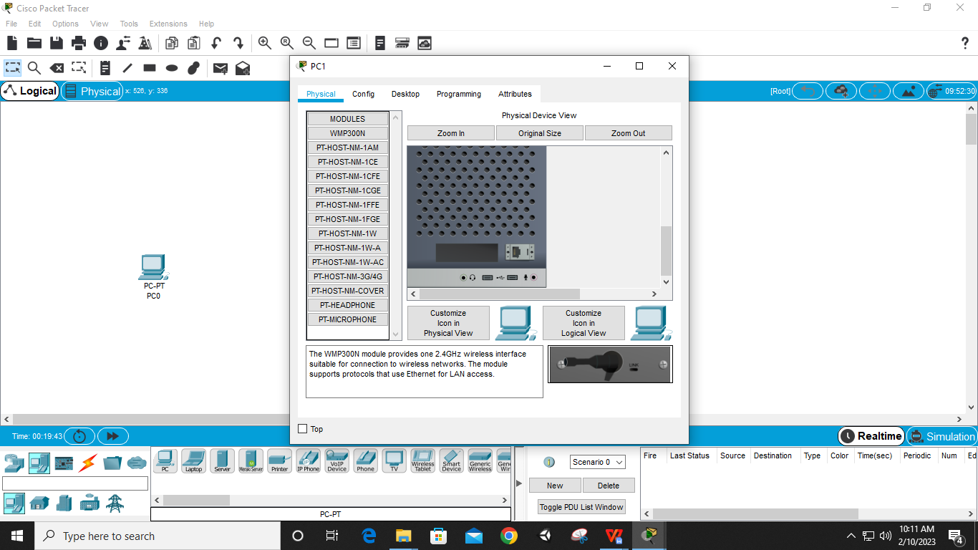

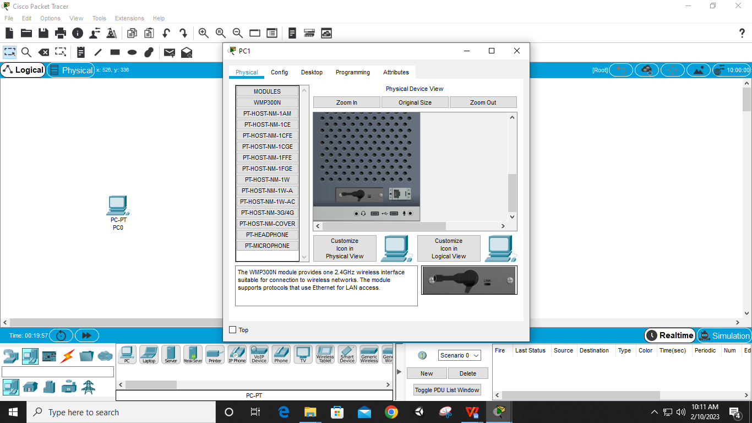

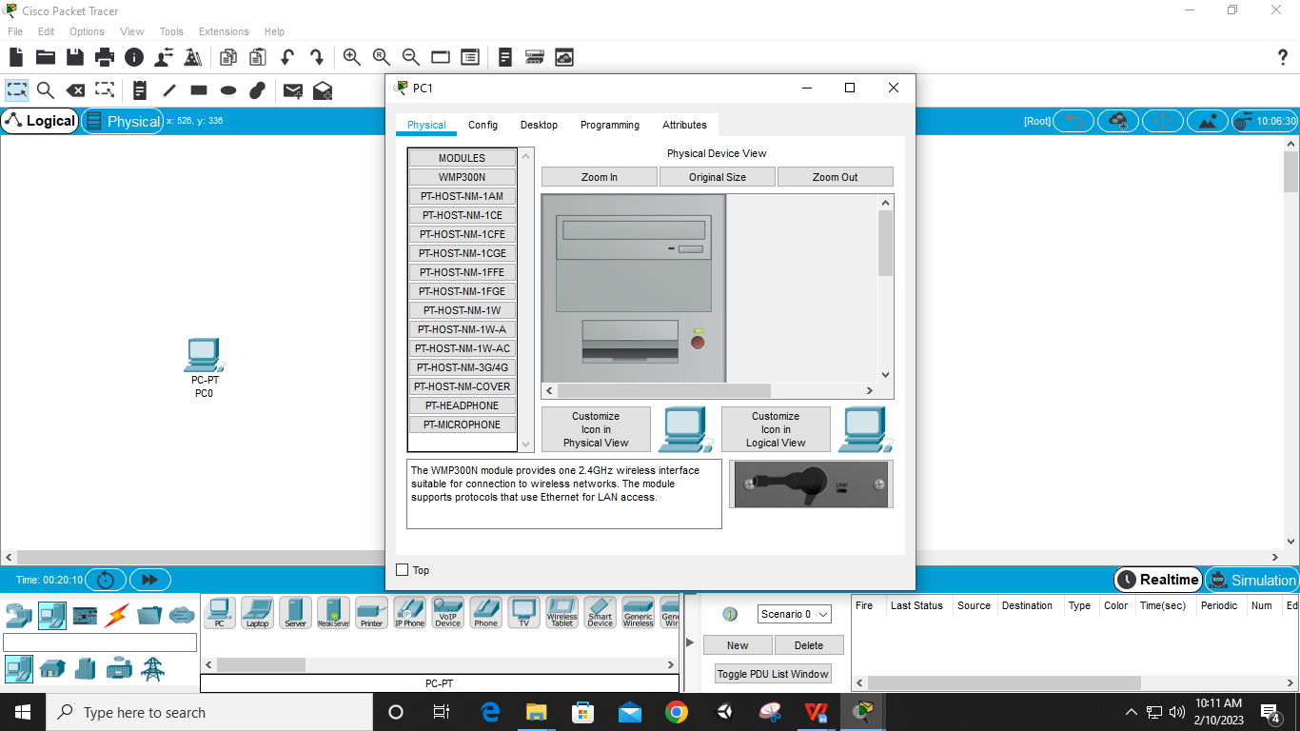

**Step 7: Select PC – Desktop – IP Configuration – Enable Static – IPv4 ‘192.168.0.2’ – Default Gateway ‘192.168.0.1’(Router IP) (for all PCs)**

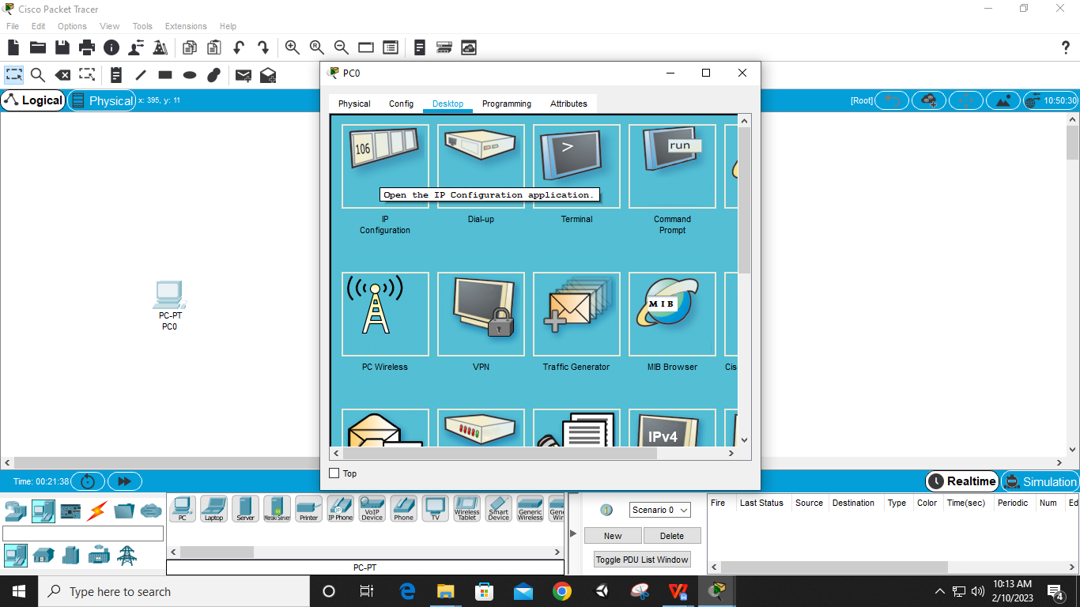

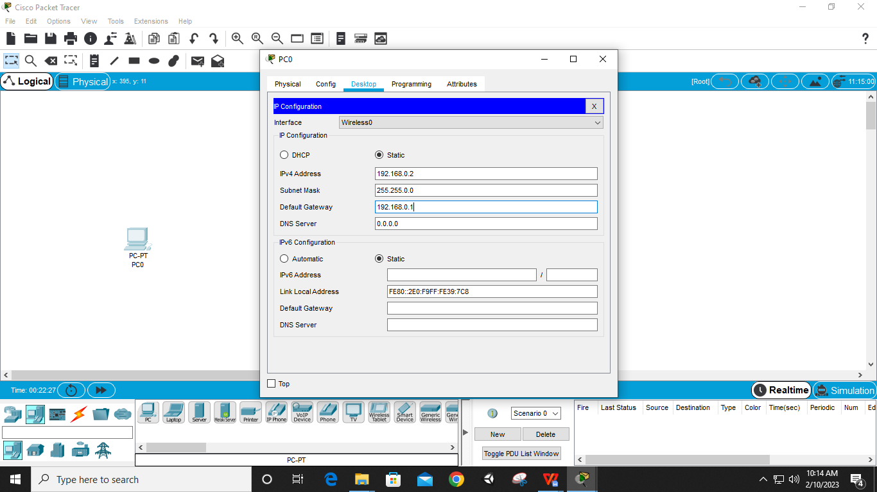

**Step 8: Select PC – Desktop – PC Wireless – Connect – After observing site information ‘Connect’ – WEP Key1 ‘0123456789’ (Router Key1) – Connect – Check ‘Link Information’ for successful connectivity to the access point (for all PCs)**

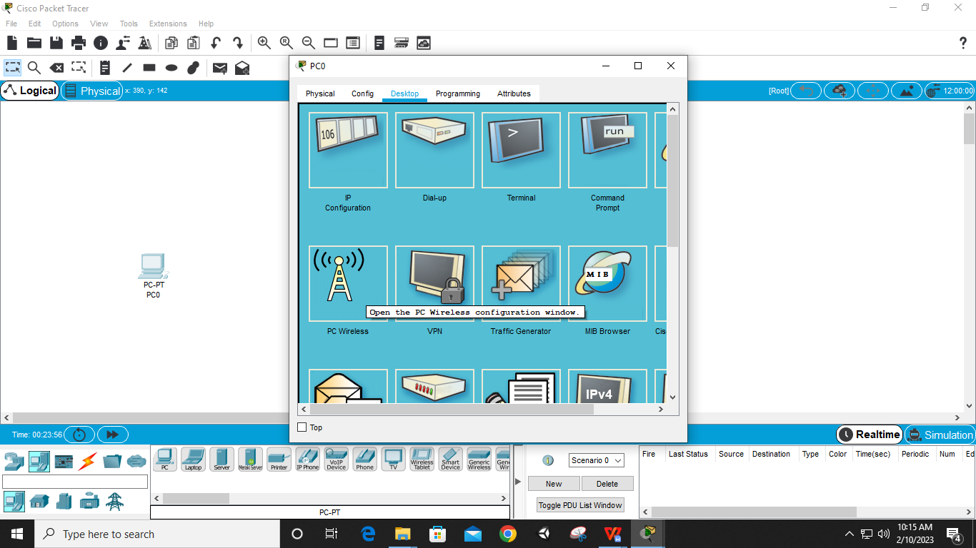

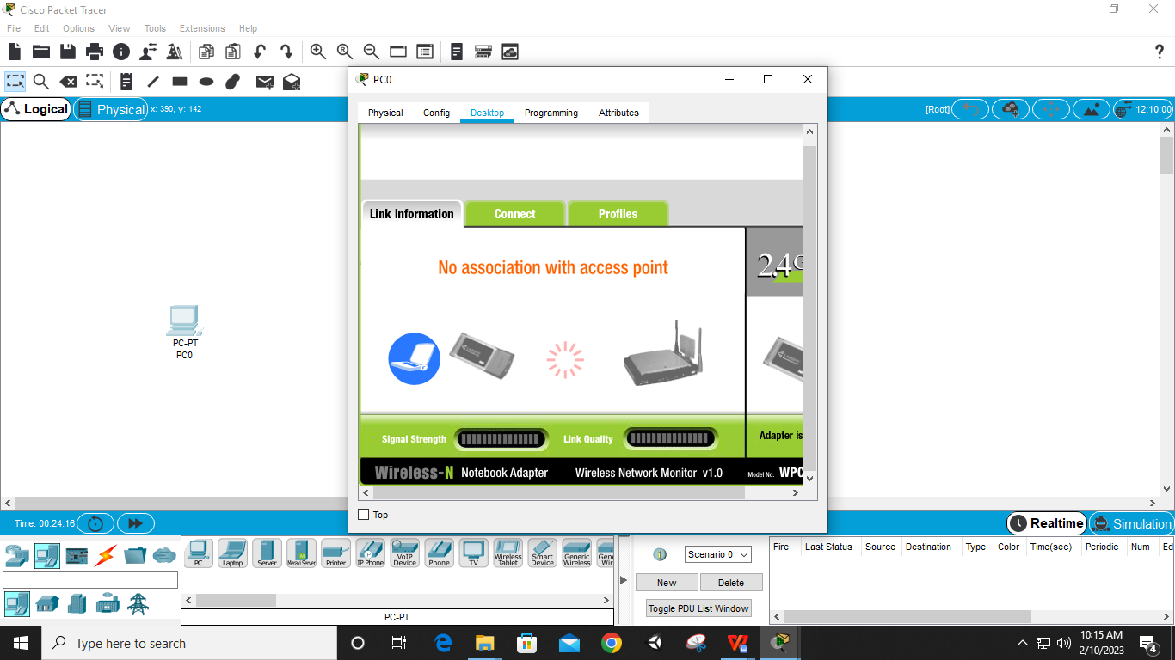

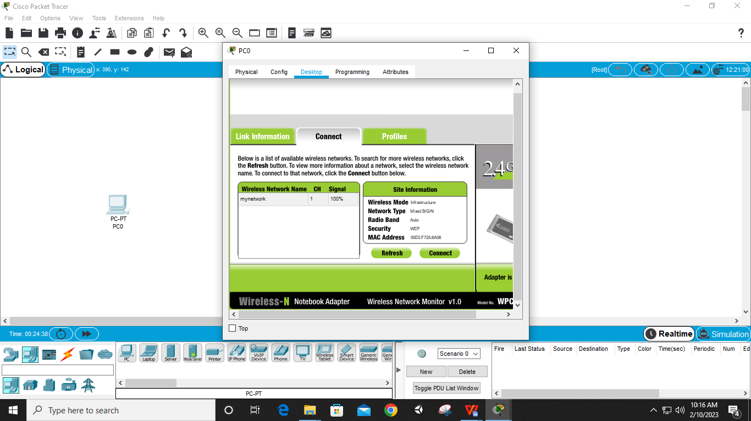

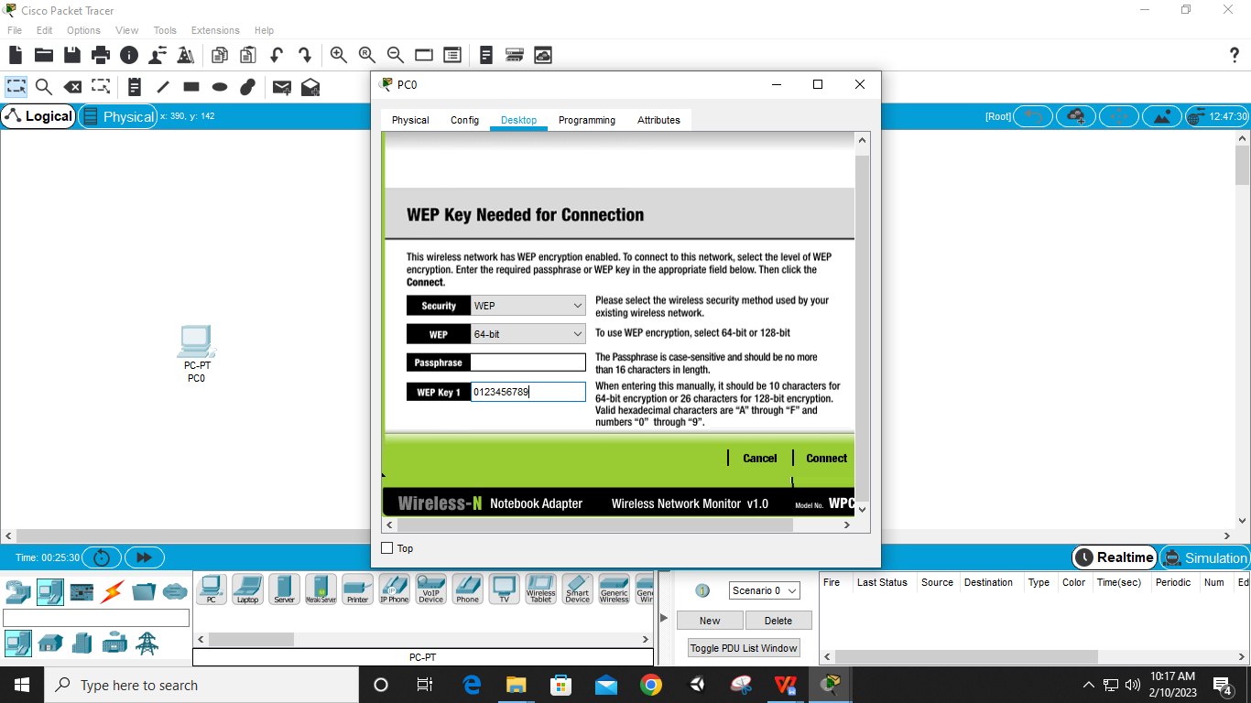

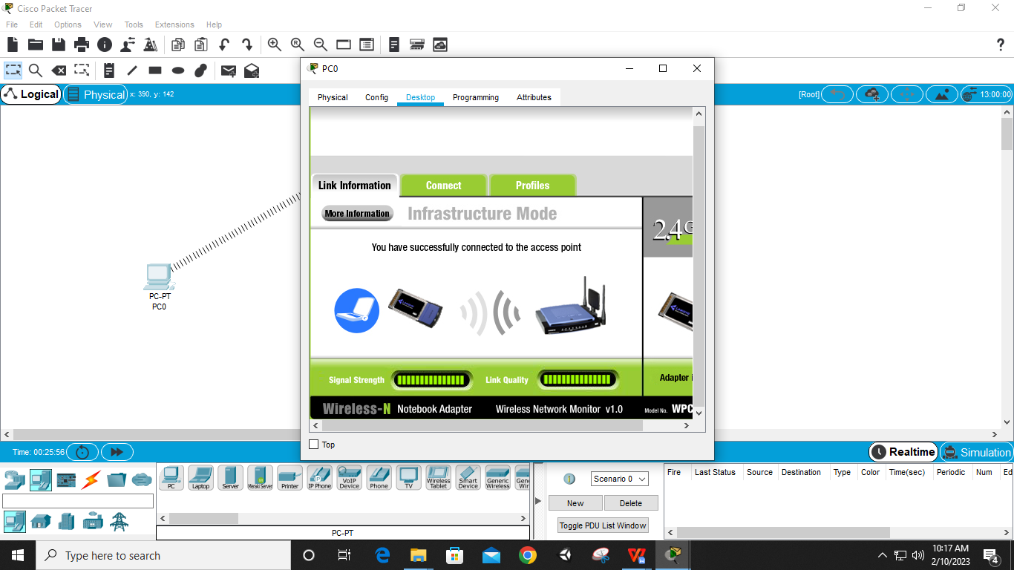

**Step 9: Connection Completed**

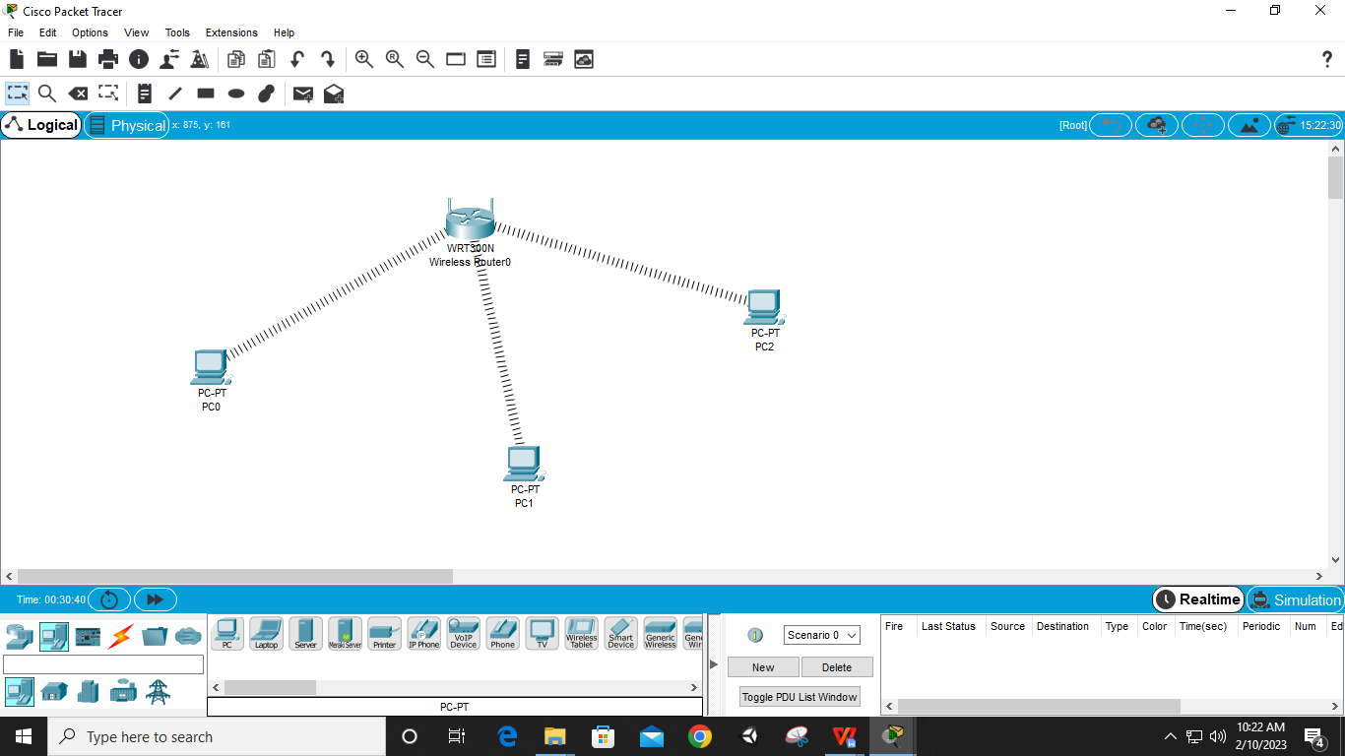

**Step 10: Send Packets to check Connection**

